Microsoft Azure App Service

# Introduction

Azure App Service is a fully managed platform for building, deploying, and scaling web applications. It enables developers to host web apps, REST APIs, and mobile backends in various programming languages including .NET, .NET Core, Java, Ruby, Node.js, PHP, or Python. App Service eliminates the need for infrastructure management, enabling focus on application logic and business needs.

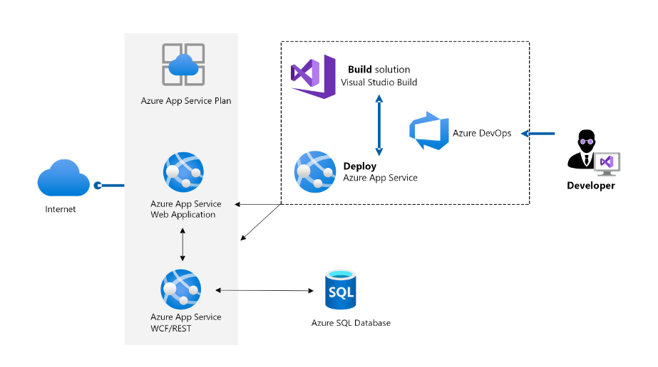

# Key Features

* Multiple Language Support: .NET / .NET Core, Java, Node.js, Python, PHP, Ruby
* DevOps Integration: Continuous integration and deployment with GitHub, Bitbucket, Azure DevOps, and Docker Hub
* Built-in Auto Scaling and Load Balancing: Automatically scales your app up or out based on demand
* Custom Domains and SSL: Easily configure custom domain names and secure apps with SSL certificates
* Global Reach: Deploy your app to any Azure region across the globe
* High Availability: Microsoft guarantees 99.95% uptime SLA

# Benefits of Azure App Service

|  |  |
| --- | --- |
| Feature | Benefit |
| Fully Managed Hosting | Focus on code without worrying about infrastructure. |
| Security | Built-in authentication, role-based access, and compliance standards. |
| Easy Monitoring | Built-in diagnostics with Azure Monitor and Application Insights. |
| Hybrid Connectivity | Connect securely to on-premises systems using VPN or ExpressRoute. |

# Types of Azure App Service Plans

* Web Apps – For hosting websites and web apps.
* API Apps – For hosting RESTful APIs.
* Mobile Apps – Backend for mobile apps, with offline sync.
* WebJobs – Background tasks or scheduled jobs that run continuously or on-demand.

# Architecture Diagram

Here’s a simplified view of how Azure App Service fits into your architecture:

+-----------------+ +------------------------+  
| User Browser | --> | Azure Front Door / CDN |  
+-----------------+ +------------------------+  
 |  
 v  
 +--------------------------+  
 | Azure App Service |  
 | (Web App/API/Mobile App) |  
 +--------------------------+  
 |  
 v  
 +-----------------------------+  
 | Azure SQL / Cosmos DB / Blob |  
 | Storage / Other Azure Services|  
 +-----------------------------+

# Use Case Scenarios

* Hosting a scalable e-commerce website
* Deploying an enterprise-grade REST API
* Running a backend for a mobile app with push notifications
* Migrating an existing on-premise web app to the cloud

# How to Create an App Service (Brief Steps)

1. Sign in to Azure Portal.
2. Go to App Services > + Add.
3. Select your Subscription, Resource Group, and App Name.
4. Choose your Runtime Stack (e.g., .NET, Node.js).
5. Select Region and App Service Plan.
6. Click Review + Create and then Create.

# Conclusion

Azure App Service provides a reliable, scalable, and easy-to-use platform for deploying and managing web apps and APIs. Its robust features, combined with Azure’s global infrastructure, make it a go-to solution for developers and businesses aiming to go cloud-native quickly and efficiently.